**University of Petroleum and Energy Studies**

School of Computer Science

Department of Cybernetics

**Graphics & Animation Tools**

**LAB FILE**

**(Session: 2020-2021)**

Course: B. Tech with Specialization in Open Source and Open Standards

Submitted To- Submitted By-

Dr. Durgansh Sharma Kunal Ojha

Associate Professor SAP ID -500063333

Department of Cybernetics Roll No. -R100217034

**Experiment 5-** Design of 3D Text using Blender

Google Drive Link- <https://drive.google.com/drive/folders/1M7wHCIcqt5ignDORxTzSUL4MYuZwm112?usp=sharing>

Step 1- Open blender and select new file type as general

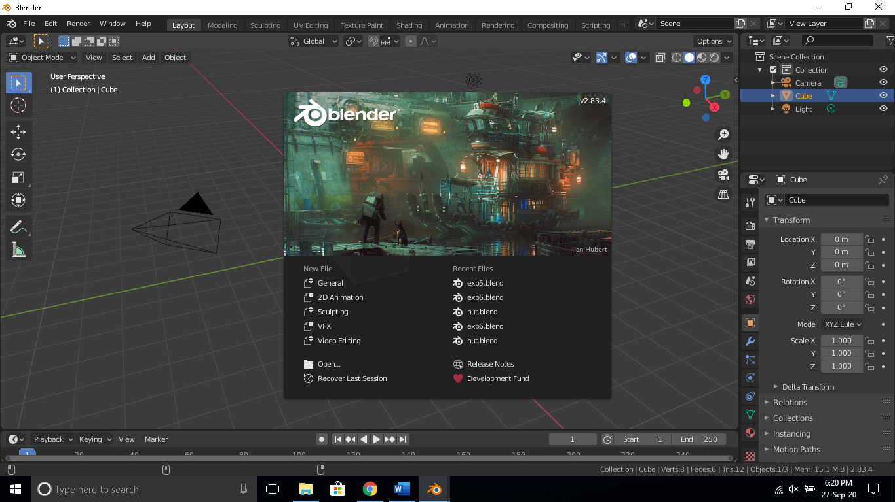

Step 2-In layout mode click on add and select text to add text, to edit text press tab and delete the text and enter your name as shown below and press tab again to exit edit text mode.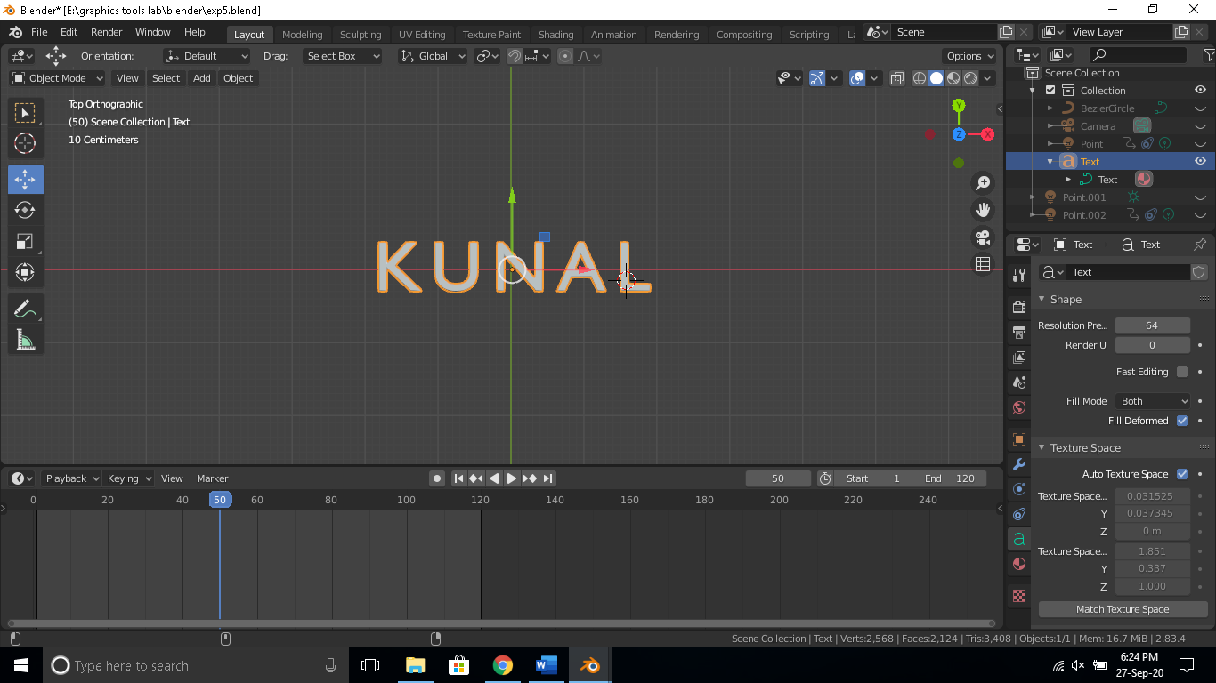

Step 3. Now add a circular path for the lights by clicking on add then curve then Bezier circle and drag to draw a circle around the text as below.

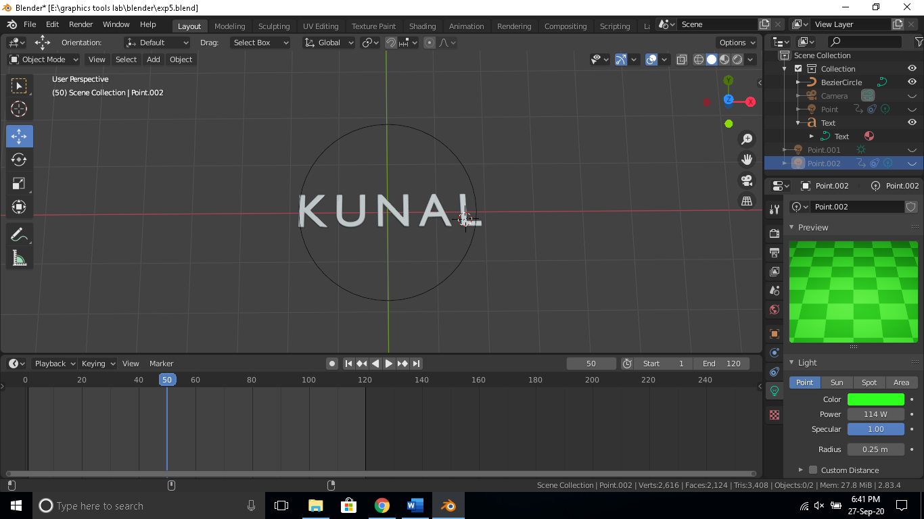

Step 4. Now add two point sourced lights and assign the circle as their path as shown below.

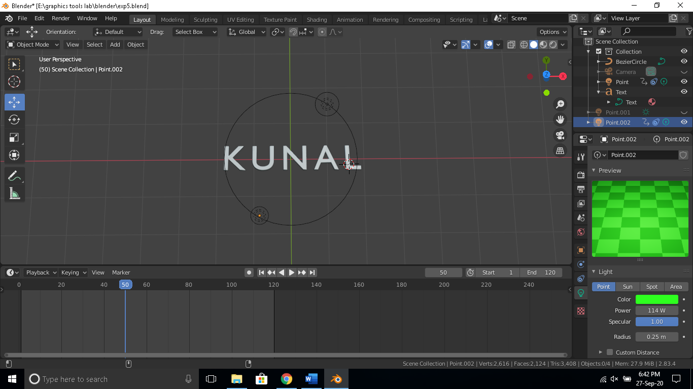

Step 5. Now animate the frames from 0 to 120 so that the light sources complete their rotation around the text in the circular path.

Step 6. Add color to text and move the camera to get a good perspective as shown below also add a light source at the top so that the top is visible.

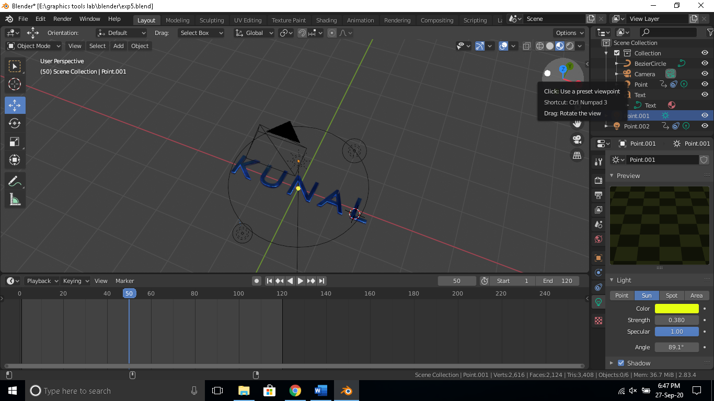

Step 7. Render the animation in Eevee engine and the output is of form .mp4,.avi etc.